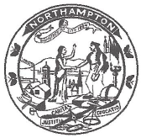
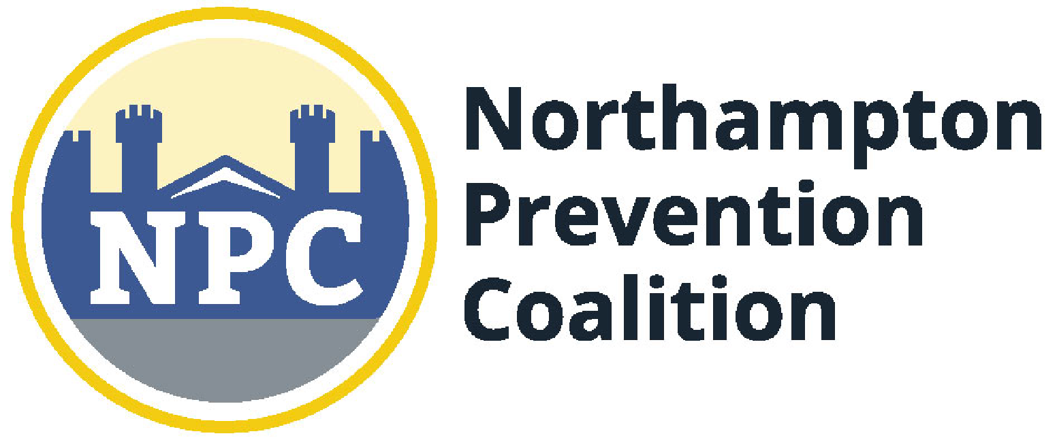Northampton Prevention Coalition Steering Committee Meeting Agenda
April 30th, 2019, 4pm-5pm
Northampton High School Boardroom, Northampton, MA
For More Information Contact: Ananda Lennox at alennox@northampton-k12.us or 413-587-1365

Topic | Time | Action to be Taken/Decision to be Made | Person responsible
Welcome | 4pm | Welcome and Ice Breaker | Ananda
Atlanta Share Out | 4:10 | - Opioid Summit: A lot of emphasis on Trauma informed care, push to view SUD not as a drug issue first, but a trauma issue. Warm hand offs were emphasized as a best practise. There was a mom in attendance who lost her son to suicide and his note blamed marijuana for changing who he was. Started a group ( out of Atlanta) called MomSupport. Latest wave of drug trend appears to be crystal meth and…(other substance could not be recalled). Handle with Care also emphasized as a best practise ( a means to be supportive and discrete and helpful towards kids in schools whose families are experiencing opioid related disruptions)  - Trump oversimplified opioid epidemic solutions. | Laurie and Karen
Health Expo and Safe Storage | 4:30 | - NPC planning for a fall expo and is seeking partners and brainstorm help: Parents only, need a draw and will most likely use Hidden in Plain Sight room display. Senior Center is available to us and free. NETA is willing to send a representative to provide show and tell and education for parents. We’d like to have healthy options for kids represented so it isn’t just an expo on bad substances. We’d like to invite NAP, NRD, YMCA, NPC ( parent’s center). Have Cherry talk about Narcan, Ruth have a station to help parents download talk they hear you app and advertise and talk up strengthening families. It would be ideal if a program was about to run. A table on what to do about bullying, a specialist to talk about sports injuries and how to treat them, a dentist; Pitch it as having “lots of resources for parents on how to navigate the teen years”. Offer someone to demonstrate meditation, chair massage, a therapist...YMCA, and Board of Health on board to partner on this.  - Safe Storage campaign for edibles; Waiting on funding through Mayor. Proposal has been submitted, edited by Laurie. Laurie also editing PSA safe storage message. Aaron Pitrat to go with Ananda to WHMP possibly next week to record it. | Laurie and Karen
WHMP PSA Safe Storage/ upcoming vape events | 4:50 | - Tuesday 5/28 NHS PTO Vape and Marijuana Education NPC, Melinda, Dr. Garcia | All
Podcast News | 4:55 | - Shelly Lenn from The Garden  - Next up: Heather Warner? TIPS/Masspack | Ananda
Updates; Upcoming Meetings or Events | 5:00 | - Next Steering Committee Meeting is Monday 5/28/19 4-5pm  - Member updates? YMCA is working to expand teen engagement and a campaign promoting their core values. NPC would love to partner with YMCA youth leadership group which currently has about 15 members. They work on projects such as coat drives, food bank, etc. The Stoughton MA Y has trauma informed training for staff and does TIC training in Brockton schools. Local Y could use some help with this for their camp staff. | All

The mission of the Northampton Prevention Coalition is: “to collaboratively initiate, coordinate, and sustain prevention and intervention efforts that reduce teen substance use in the City of Northampton.”

